**DAY 4**

ClassExercise_01:

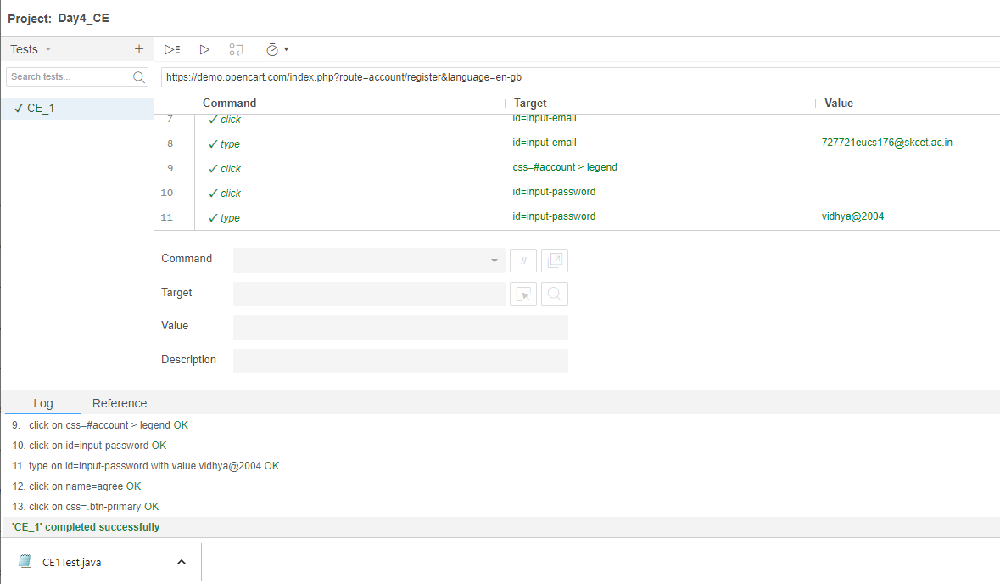

ClassExercise_02:

Code:

package com.day4;

import org.openqa.selenium.By;

import org.openqa.selenium.WebDriver;

import org.openqa.selenium.WebElement;

import org.openqa.selenium.chrome.ChromeDriver;

import org.openqa.selenium.chrome.ChromeOptions;

import io.github.bonigarcia.wdm.WebDriverManager;

public class CE_2 {

public static void main(String[] args) throws InterruptedException {

// TODO Auto-generated method stub

ChromeOptions co=new ChromeOptions();

co.addArguments("--remote-allow-origins=*");

WebDriverManager.chromedriver().setup();

WebDriver d=new ChromeDriver();

d.get("https://demo.opencart.com/index.php?route=account/register&language=en-gb");

d.manage().window().maximize();//maximize screen

WebElement fname= d.findElement(By.id("input-firstname"));

fname.sendKeys("vidhu");

WebElement lname=d.findElement(By.id("input-lastname"));

lname.sendKeys("s");

WebElement mail=d.findElement(By.id("input-email"));

mail.sendKeys("727721eucs185@gmail.com");

WebElement pawd=d.findElement(By.id("input-password"));

pawd.sendKeys("12345");

Thread.sleep(3000);

d.findElement(By.id("input-newsletter-yes")).click();

d.findElement(By.name("agree")).click();

d.findElement(By.xpath("//button[@type=\"submit\"]")).click();

}

}

Output:

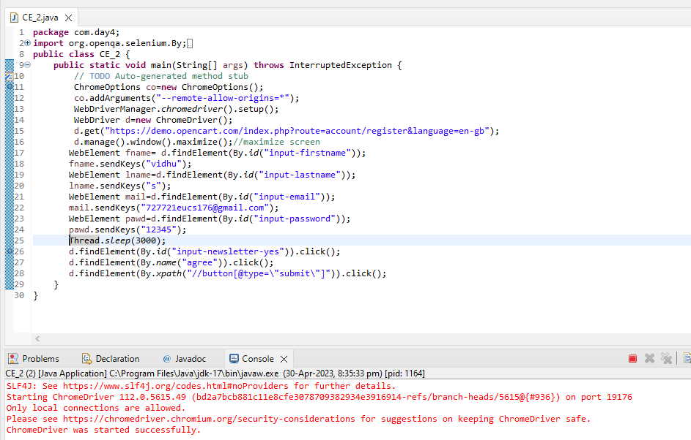

ClassExercise_03:

Code:

package com.day4;

import org.openqa.selenium.By;

import org.openqa.selenium.WebDriver;

import org.openqa.selenium.WebElement;

import org.openqa.selenium.chrome.ChromeDriver;

import org.openqa.selenium.chrome.ChromeOptions;

import io.github.bonigarcia.wdm.WebDriverManager;

public class CE_3 {

public static void main(String[] args) throws InterruptedException {

// TODO Auto-generated method stub

ChromeOptions co=new ChromeOptions();

co.addArguments("--remote-allow-origins=*");

WebDriverManager.chromedriver().setup();

WebDriver d=new ChromeDriver();

d.get("https://demo.opencart.com/index.php?route=checkout/voucher&language=en-gb");

d.manage().window().maximize();//maximize screen

WebElement rname=d.findElement(By.xpath("//*[@id=\"input-to-name\"]"));

rname.sendKeys("tamil");

WebElement rmail=d.findElement(By.xpath("//*[@id=\"input-to-email\"]"));

rmail.sendKeys("727721eucs163@gmail.com");

WebElement mname=d.findElement(By.xpath("//*[@id=\"input-from-name\"]"));

mname.sendKeys("vidhu");

WebElement mmail=d.findElement(By.xpath("//*[@id=\"input-from-email\"]"));

mmail.sendKeys("727721eucs185@gmail.com");

d.findElement(By.xpath("//*[@id=\"input-theme-7\"]")).click();

WebElement msg=d.findElement(By.xpath("//*[@id=\"input-message\"]"));

msg.sendKeys("Happy Birthday Tamiluu");

WebElement amt=d.findElement(By.xpath("//*[@id=\"input-amount\"]"));

amt.sendKeys("5");

Thread.sleep(1000);

d.findElement(By.xpath("//*[@id=\"form-voucher\"]/div[8]/div/div/input")).click();

d.findElement(By.xpath("//*[@id=\"form-voucher\"]/div[8]/div/button")).click();

}

}

Output:

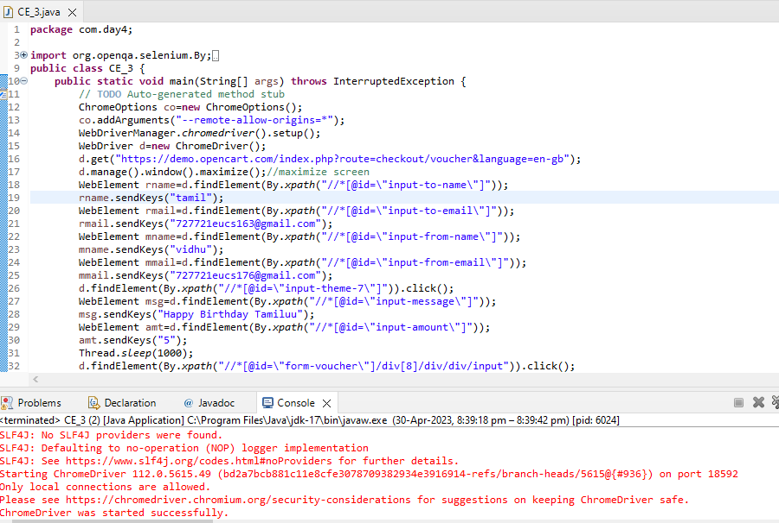

ClassExercise_04:

Code:

package com.day4;

import org.openqa.selenium.By;

import org.openqa.selenium.WebDriver;

import org.openqa.selenium.chrome.ChromeDriver;

import org.openqa.selenium.chrome.ChromeOptions;

import io.github.bonigarcia.wdm.WebDriverManager;

public class CE_4 {

public static void main(String[] args) throws InterruptedException {

// TODO Auto-generated method stub

ChromeOptions co=new ChromeOptions();

co.addArguments("--remote-allow-origins=*");

WebDriverManager.chromedriver().setup();

WebDriver d=new ChromeDriver();

d.navigate().to("https://j2store.net/free/");

d.manage().window().maximize();//maximize screen

Thread.sleep(4000);

d.findElement(By.linkText("Clothing (5)")).click();

d.navigate().back();

d.navigate().forward();

d.navigate().refresh();

d.close();

}

}

Output:

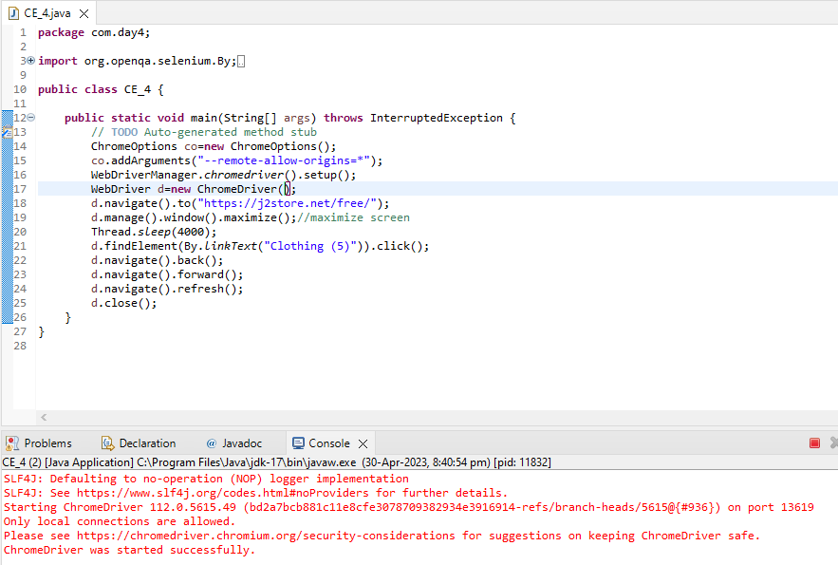

ClassExercise_05:

1.Code:

package com.day4;

import org.openqa.selenium.By;

import org.openqa.selenium.WebDriver;

import org.openqa.selenium.chrome.ChromeDriver;

import org.openqa.selenium.chrome.ChromeOptions;

import io.github.bonigarcia.wdm.WebDriverManager;

public class CE_5 {

public static void main(String[] args) {

// TODO Auto-generated method stub

ChromeOptions co=new ChromeOptions();

co.addArguments("--remote-allow-origins=*");

WebDriverManager.chromedriver().setup();

WebDriver d=new ChromeDriver();

d.navigate().to("https://j2store.net/free/");

d.manage().window().maximize();//maximize screen

String curl=d.getCurrentUrl();

String eurl="https://j2store.net/free/";

if(curl.equals(eurl))

System.out.println("URL matches");

else

System.out.println("URL not matches");

d.findElement(By.linkText("Clothing (5)")).click();

String curr=d.getCurrentUrl();

String expe="https://j2store.net/free/index.php/shop?filter_catid=11";

if(curr.equals(expe))

System.out.println("URL Matches");

else

System.out.println("URL Not matches");

}

}

Output:

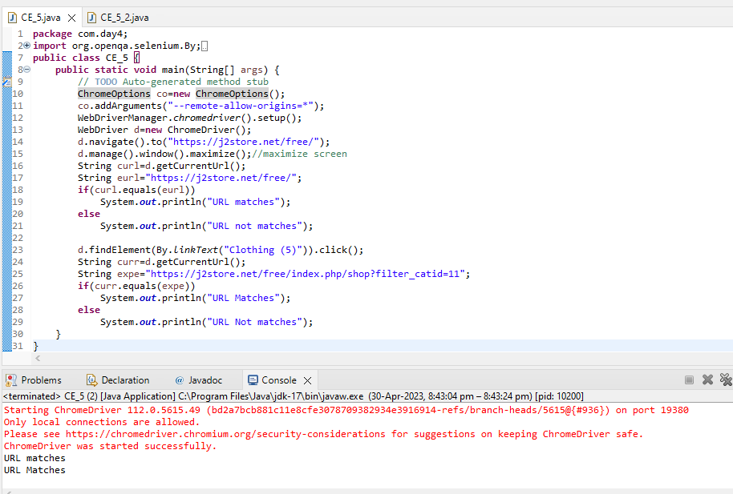

2.Code:

package com.day4;

import java.util.List;

import org.openqa.selenium.By;

import org.openqa.selenium.WebDriver;

import org.openqa.selenium.WebElement;

import org.openqa.selenium.chrome.ChromeDriver;

import org.openqa.selenium.chrome.ChromeOptions;

import io.github.bonigarcia.wdm.WebDriverManager;

public class CE_5_2 {

public static void main(String[] args) {

// TODO Auto-generated method stub

ChromeOptions co=new ChromeOptions();

co.addArguments("--remote-allow-origins=*");

WebDriverManager.chromedriver().setup();

WebDriver d=new ChromeDriver();

d.navigate().to("https://j2store.net/free/");

d.findElement(By.linkText("Clothing (5)")).click();

List<WebElement> products=d.findElements(By.xpath("//h2[@itemprop=\"name\"]"));

for(int i=0;i<products.size();i++)

System.out.println(products.get(i).getText());

}

}

Output: 